**Dir**

The dir command lists the contents of the current directory.

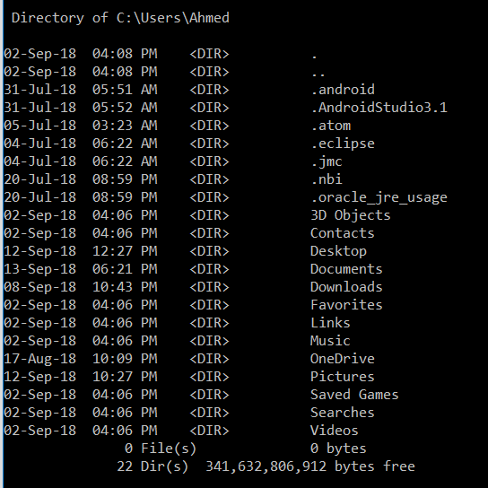

**cd**

To change directories, use the cd command

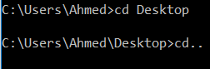

**mkdir**

This one is used to make a directory

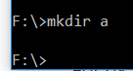

**rmdir**

To remove a directory, use this command.

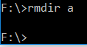

**del**

This is the command to delete files



**Driverquery**

For a list of all drivers installed on your system

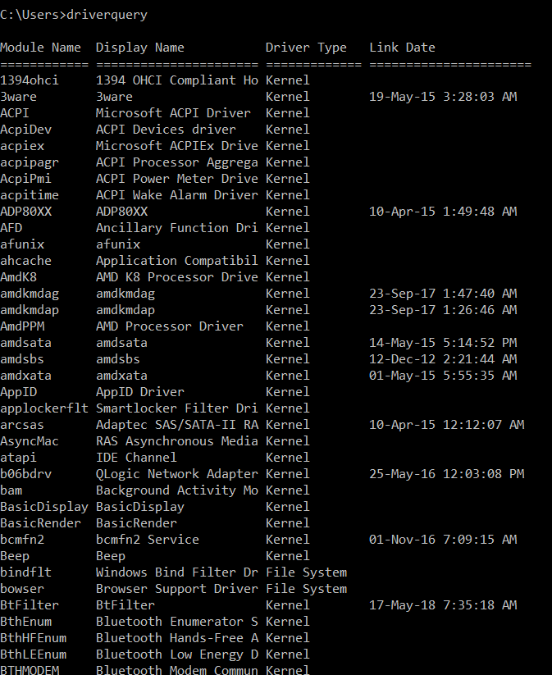

**Systeminfo**

The command to retrieve extensive information about your system, including Windows serial number, computer model, and available RAM.

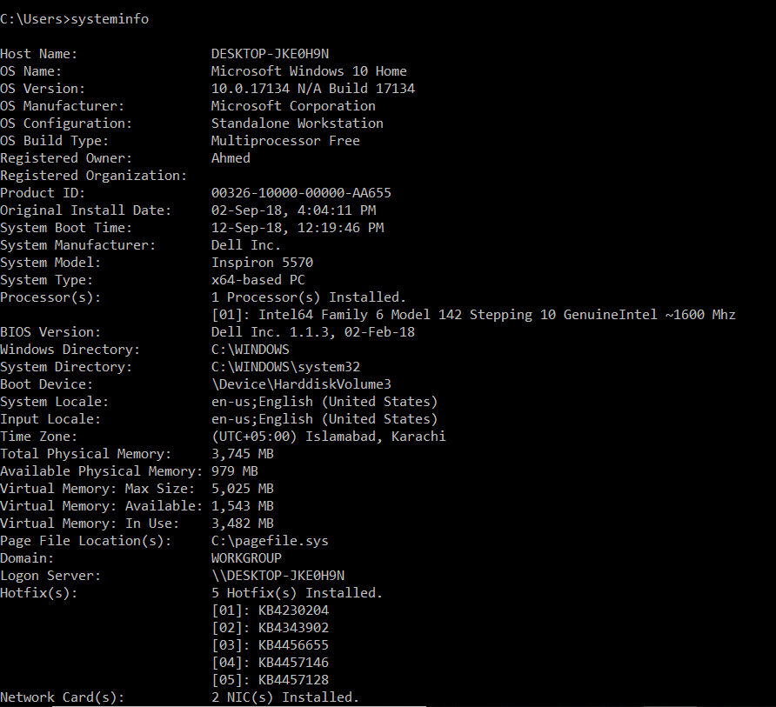

**Arp**

Address Resolution Protocol is used to map IP address to the hardware address

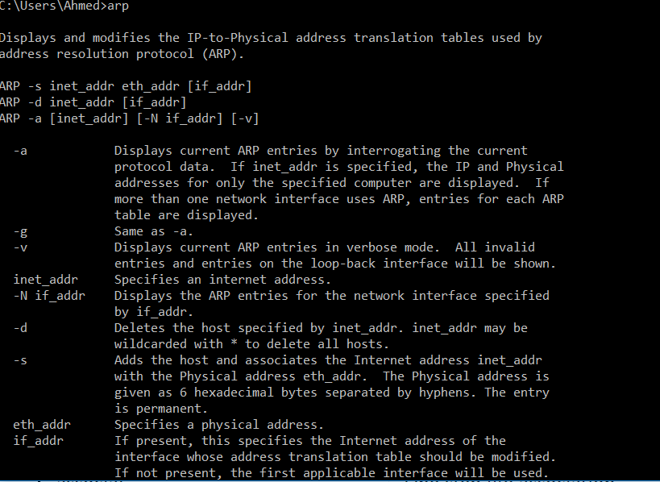

**Bcdboot**

Used to create and repair a system partition

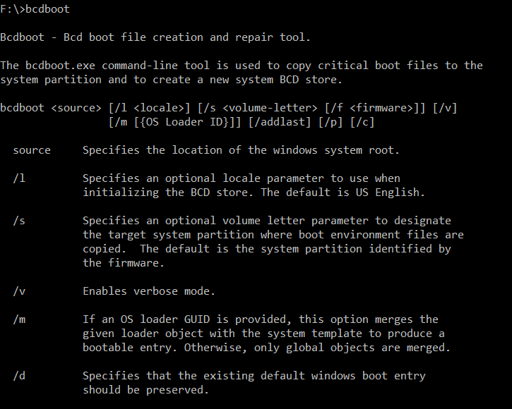

**Chcp**

 Displays the number of active console code page

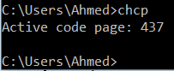

**color**

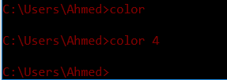

**Exit**

Close the command prome



**Ipconfig**

Display and change Windows IP configuration

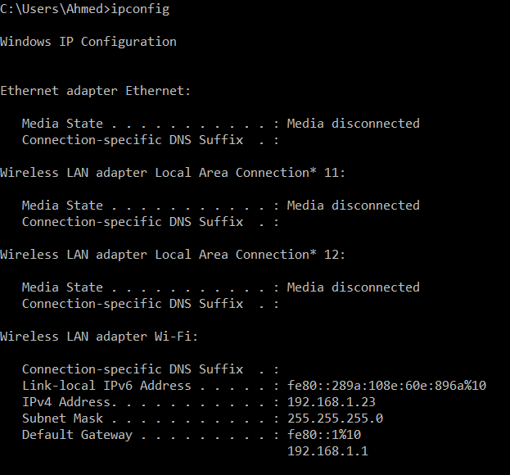

**Label**

Used to change the name of a disk

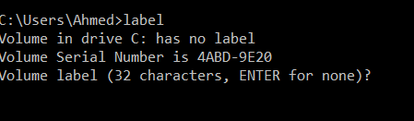

**Logman**

Used to manage performance monitor logs\

**Logoff**

Log a user off

**Ping**

Test network connection to a computer

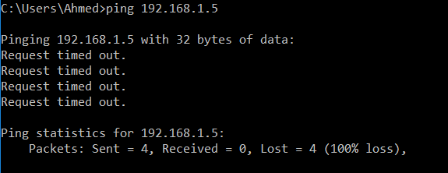

**Systeminfo**

Display detailed configuration information about the computer



**Time**

Show and change time



**Date**

Set and show date



**Tree**

Display a folder structure in the form of a graphical tree

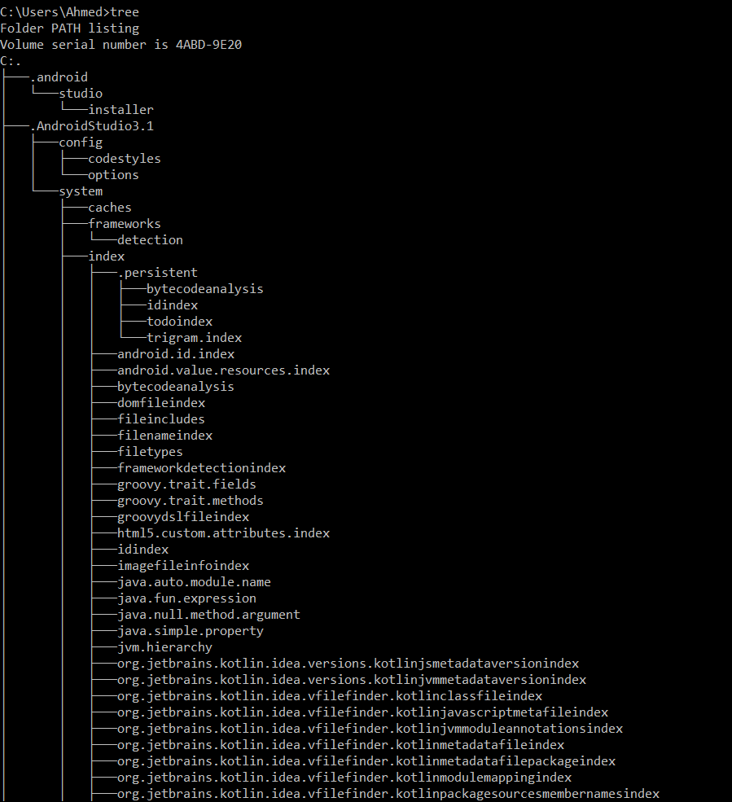

**Vssadmin**

Show shadow copy backups, installed shadow copy writers and providers

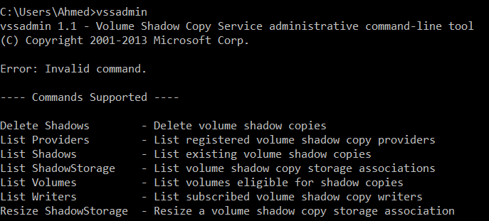

::

Comment

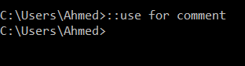

Help

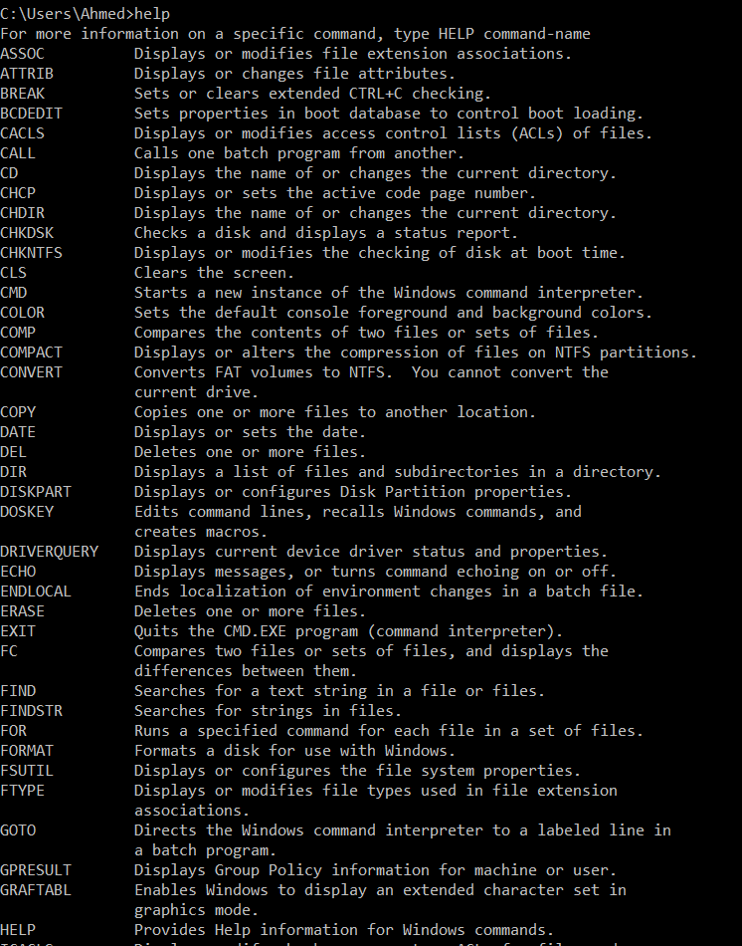

More

Show all the data of file



**SORT**

Sorts input.

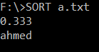

**VER**

Displays the Windows version.

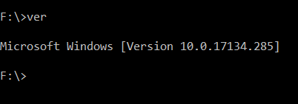

**Whoami**

Show name of desktop

